KENDRIYA VIDYALAYA SANGATHAN, JABALPUR REGION
PERIODIC TEST-3, 2018-19
MARKING SCHEME FOR SCIENCE
CLASS-X
Q. No | EXPECTED ANSWER | VALUE POINT | MARKS  (80)
1 | SECTION-A  Forelimbs of frog, Forelimbs of a human. | 1/2,1/2 | 1
2 | Decomposers break down the complex organic substances in the dead remains  and waste products of organisms into simple organic substances that go into the soil and are used up again by the plants. | 1 | 1
3 | Chemical name: Ethanol. Molecular formula: C₂H₅OH  ^{Conc.}  ^{H}₂^{SO}₄  CH₃CH₂OH CH₂=CH₂ + H₂O  443K | 1/2+1/2  1 | 2
4 | (i) The receptors collect information about changes in the environment around  us in the form of stimuli. The information is then passed in the form of nerve  impulses to the central nervous system where it is interpreted and  appropriate instructions are sent to the effectors for response.  (ii) Reflex actions, Involuntary actions.  instructions  (ii) Reflex action is the immediate response to a sudden impulse that occurs ia a fraction of seconds at the level of spinal cord.Walking is a voluntary action controlled by the brain and takes more time. | 1  1/2,1/2  1 | 2
5 | It is a Concave mirror.  Labelled ray diagram:  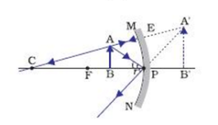 | 1/2  1+1/2 | 2
6 | (i) Substance ‘X’ is Quick lime.(Calcium oxide). Formula : CaO  (ii) Reaction: CaO + H₂O Ca (OH) ₂ + Heat.  (iii) Yes. In this reaction two substances combine to form a single product with the  evolution of heat. The decomposition reactions require energy in the form of  heat, light or electricity for breaking down one substance into two or more  substances. | 1/2,1/2  1  1 | 3
7 | (i) Chemical name: Sodium hydrogen carbonate.  (ii) 2NaHCO₃ Na₂CO₃ + H₂O + CO₂  (iii)Baking soda is a base. Milk is made slightly alkaline to prevent the curdling of milk  because it neutralizes the lactic acid produced in the milk by the action of bacteria.  (iv) Na₂CO₃.10 H₂O | 1/2  1  1  1/2 | 3
8 | (i) A homologous series is a group of organic compounds having the same functional  group and similar chemical properties in which the successive compounds  differ by a CH₂ unit. They can be represented by the same general formula. For  example: general formula for Alkenes can be written as C_{n}H_{2n+2} where  n=1, 2, 3, 4 The members CH₄,C₂H₆,C₃H₈ differ by a CH₂ unit and a molecular  mass of 14u.  (ii) They are isomers with the same molecular formula but different structural  formula.  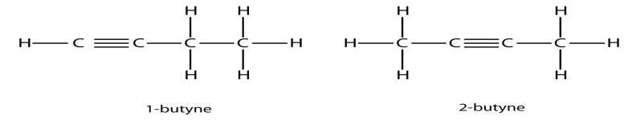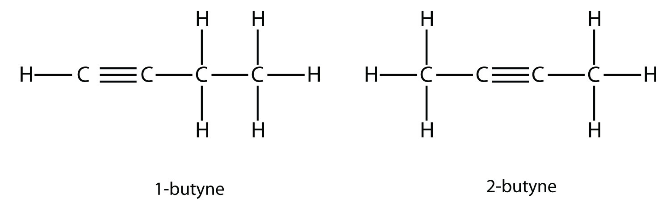 | 1, 1/2  1/2  1/2+1/2
 | OR  (i) CH₄+Cl₂ ^{SUNLIGHT} CH₃Cl + HCl  (ii) A mixture of oxygen-ethyne flame is extremely hot and produces a very  high temperature used for welding. Ethyne burns completely producing a  blue flame. Burning of ethyne in air produces a sooty flame due to  incomplete combustion which is not hot enough to melt metals for welding.  (iii) Functional group: Ketone.  (iv) | 1  1  1/2  1/2 | 3
9 | Chemotropism, Phototropism  Cytokinins, Abscissic acid  Pancreas  Iodine is necessary for the thyroid gland to make thyroxin hormone. | 1/2,1/2  1/2,1/2  1/2  1/2 | 3
10 | (i) Figure: Spore formation in Rhizopus.  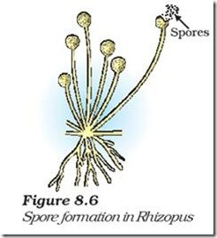  An organism will be benefitted if it reproduces through spores because:  (a) it is a simpler and faster mode of reproduction (b) Spores are small, light and get easily dispersed (c) spores bear thick resistant covering to enable them to survive in unfavourable conditions.(any 2 points)  (ii) The organism simply breaks up into smaller pieces upon maturation and  these fragments grow into new individuals. Method called as Fragmentation. | 1  1  1 | 3
 | OR  Name of the process: Regeneration  When a Planaria is cut into three pieces ,each of its pieces grow into separate individual; specialized cells proliferate; mass of cells get differentiated into various cells and tissues.  Another example of an organism showing the characteristics is Hydra | 1/2  1  1  1/2
11 | (i) Segment of DNA which is functional and are made of nucleic acids and  protein.  (ii) Red hair – Mother – Recessive ∴ bb. Black hair – father Dominant ∴ BB  Parents F₁ Father Mother BB x bb Bb The child will have black hair. | 1  1  1 | 3
12 | (i) Change in attitude, life-style, minimize the use of disposable articles, adopt  the strategy of Re-use ,Recycle, Re-cover.(any 2 points)  (ii) Hawk. Biological magnification. | 2  1/2,1/2 | 3
13 | (i) 1 Dioptre is the power of a lens whose focal length is 1 metre.  (ii) For a person having a normal vision, least distance of vision d=25 cm.  Maximum power of accommodation P=100/f = 100/d = 100/25 = 4D. | 1  1  1 | 3
14 | (i) The cord of the electric heater is made of Copper. It does not glow as  negligible heat is produced in it by the passing current due to extremely low  resistance.  (ii) R= 20Ω, I = 5A,t= 30 s  Heat developed = I²RT = 5x5x20x30 = 15,000 J=15k J  OR  (i) Pure Tungsten has a high resistivity, high melting point. Does not melt at a high  temperature.  (ii) Total resistance will increase.Current flowing through the circuit will be low.  If one appliance is switched off or gets damaged, all the other appliances will  Also stop as the electricity supply will be cut off.  (iii) The resistance of a wire is inversely proportional to its area of cross section. | 1  2  1  1  1 | 3
15 | (i) If the lines intersect, then at the point of intersection there would be two directions for the same magnetic field which is not possible.  (ii) Magnetic field around a current carrying Solenoid.  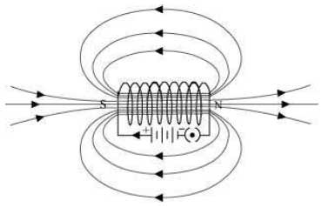  The magnetic field also gets reversed. | 1  1,1/2  1/2 | 3
16 | (i) High melting/boiling points as considerable energy is needed to break the strong  inter-ionic bonds. Conduct electricity in the molten state due to the free  movement of ions.  (ii) Calcination: it is carried out by heating the ore in the absence of air, done to  convert Carbonate ores into oxide form.  HEAT  Example: ZnCO₃ ZnO + CO₂  (iii) Fe₂O₃ + 2Al 2Fe + Al₂O₃  Reaction name: Thermit reaction. | 1+1  1/2  1  1  1/2 | 5
17 | (a) Noble gas- G , Halogen - F  (b) Most active metal – B  (c) Most electronegative in 3rd period- F  (d) Ionic bond  (e) Oxide formed by C would be basic.  OR  (i) Limitation of Newland’s attempt: Elements only upto Calcium could be placed  into eight groups.Could not be applied to elements with higher atomic masses.  Limitation of Mendeleev’s attempt: Anomalous position of Hydrogen/isotopes  could not be placed.  (ii) Henry Moseley  (iii) Only two,Lithium and Beryllium are metals.  (iv) ‘Properties of elements are a periodic function of their atomic number’. | 1/2,1/2  1  1  1  1  2  1  1  1 | 5
18 | (i) Plasma transports food,CO₂ and nitrogenous wastes in dissolved form.Lymph carries digested and absorbed fat from intestine and drains excess fluid from extracellular space back into blood.  (ii) Pulmonary veins(oxygenated blood),Left atrium,left ventricle,aorta,arteries,  Arterioles,capillaries,tissues,cells.  (iii) Warm blooded animals have high energy needs and need more oxygen to produce energy.It is important that the oxygenated and de-oxygenated blood do  not get mixed up.  (iv) Xylem and Phloem. | 1  2  1  1/2,1/2 | 5
19 | (i) Ovary: production of ovum,production of hormones oestrogen & progesterone.  Oviduct: site of fertilisation, carries egg or fertilise ovum to the uterus.  Uterus: site of implantation,development,nourishment & protection of the embryo.  (ii) Methods of contraception: Barrier or mechanical method(condom/diaphragm):  Prevents the meeting of sperms and ova.  Chemical method(oral pills): changes the hormonal balance of the female partner  so that eggs are not released.  Loop or Copper-T : placed in the uterus tom prevent pregnancy. | 1+1+1  1+1 | 5
20 | (i) Due to excessive curvature of the eye lens, elongation of eyeball  Correction: by using a concave lens.  (ii) Given, v= -100cm,u = ∞  Using lens formula,1/f = 1/v-1/u = 1/f = 1/-100 – 1/∞ = -1/100  f =-100cm=-1m  Power , P = 1/F = 1/-1= -1D  OR  (i) The distance between eye lens and retina is the image distance. It is fixed and cannot be changed. When we increase the distance of an object from the eye, there is no change in the image distance.  (ii) It is due to atmospheric refraction of starlight in a medium of gradually  changing refractive index.  (iii) The sun is near the horizon and sunlight has tom travel a long distance to reach us. Most of the blue colour and shorter wavelength is scattered from our line of sight. Light reaching us is of longer wavelength, red colour.  (iv) There is no atmosphere containing air in the outer space to scatter sunlight.  (v) It arises due to gradual weakening of the ciliary muscles and diminishing  flexibility of the eye lens. | 1  2  1+1  1  1  1  1  1 | 5
21 | (i) Stretch the thumb, forefinger and the middle finger of the left hand in such a way that they are mutually perpendicular. If the first finger points in the direction of magnetic field and the second in the direction of current, then the thumb will point in the direction of motion or the force acting on the conductor.  (ii) A current carrying conductor placed in a magnetic field experiences a force, the direction of the force is given by Fleming’s left hand rule. An electric motor converts electrical  energy to mechanical energy.  (iii) Armature: current carrying armature coil experiences a torque in the magnetic field and begins to rotate. Converts electrical energy to mechanical energy.  Brushes: maintain a sliding contact with the split rings and allows a continuous flow of current from the external battery to the armature coil.  Split rings: acts as a commutator and reverses the direction of current in the armature coil after every half rotation. | 1  1  3 | 5
22 | SECTION-B  (i) Hydrogen gas.  (ii) The red litmus paper is dipped in NaOH solution and dried so that blue  litmus paper is obtained. Now, a few drops of HCl are put on the blue litmus  paper which turns red. Thus, HCl is tested.  OR  (i) Zinc is more reactive than Copper and will displace it .Blue colour of Copper  Sulphate will fade and finally become colourless.  Zn + CuSO₄ ZnSO₄ + Cu  (ii) No change/reaction as Zinc is less reactive than Aluminium. | 1  1  1/2  1  1 | 2
23 | (i) Ethanoic acid has a smell like vinegar.  (ii) It reacts with Sodium bicarbonate and gives a brisk effervescence with the evolution  of a colourless and odourless gas Carbon di oxide. | 1  1 | 2
24 | A: Plumule, B: Radicle, C: Seed coat, D: Cotyledon. | 1/2 x 4 | 2
25 | (i) It is a common and rapid type of reproduction in which new generations are created  by a single individual.  (ii) Amoeba: Binary fission. Yeast: Budding. | 1  1/2+1/2 | 2
26 | (i) An Ammeter is a low resistance device and is always connected in series with  the circuit so that maximum current can pass through it for accurate  measurement of current.  (ii) R = V/I, R = 10V/2A = 5Ω | 1  1 | 2
27 | (i) 2: Orange, 6: Indigo.  (ii) At number 7: Violet.  (iii) Rainbow formation. | 1/2,1/2  1/2  1/2 | 2

